Functional Test Report
Inji Mobile Wallet 0.22.1

6 May 2026


Document History
It outlines the strategy used to ensure a comprehensive evaluation.

Version | Author | Date | Review | Affected Sections
V2.0 | Nitin | 06/05/2026 | - Chaitanya Kesiraju  - Ragini Krishna | Updated for release 0.22.1

Contents

Introduction 4
Overview and Scope 4
Test Organization 4
Test Environment 5
Automation Result Mimoto API 5
Known Issues Metrics 6
Conclusion 7
QA Approval 8
Appendix 8
Appendix A: Versions 8
Appendix B: Acronyms 8

Introduction
The scope of this patch release is limited to addressing the defect “INJI Wallet – VP verification with iOS wallet is not working,” identified during the testing of INJI Verify.
This release is focused solely on the resolution of the issue. From the QA perspective, sanity testing has been performed to validate the fix, and basic verification has been carried out on INJI Mobile to ensure there is no impact on critical functionalities.
Comprehensive testing covering functionality, configurability, and extensibility is out of scope for this patch release.

Overview and Scope
- MOSIP IDA, Health VC, Life VC, Land VC, and Farmer VC are Verified.
- QR login is Verified (Cross device and same device)
- VC activation is Verified.
- MDL VC is Verified.
- Backup and restore are Verified.
- PIN VC is Verified.
- Unlock with biometrics is Verified.
- Key management is Verified.
- Language selection is Verified.
- SD-JWT VC download is Verified.
- SVG download is Verified.
- Credential Offer Flow is Verified.
- OVP sharing with all the API - preregistered, DID and redirect

Test Organization
Table 1: Test Organization
Name | Functional Role | Responsibilities
Nitin Hegde | QA Lead | Verify the functionality, stability of the application, and report review.
Chaitanya K | QA Manager | Reviewing the test execution and review of the report.
Ragini Krishna | Senior QA Manager | High-level governance and executive reviews of reports and execution.

Test Environment
Table 2: Test Environment
Images (qa-inji1 env)
injistackqa/inji-verify-service:0.18.x
injistackqa/inji-verify-ui:0.18.x
injistackqa/inji-certify-with-plugins:0.14.x
injistackqa/inji-web:develop
injistackqa/apitest-mimoto:0.22.x

Images (released env)
mosipid/mimoto:0.22.0
mosipid/apitest-mimoto:0.22.0
mosipid/inji-verify-service:0.17.0
mosipid/inji-verify-ui:0.17.0
mosipid/inji-certify-with-plugins:0.14.0
mosipid/inji-web:0.16.0
mosipid/esignet-with-plugins:1.6.2
mosipid/authentication-service:1.3.0
mosipid/authentication-internal-service:1.3.0
mosipid/authentication-otp-service:1.3.0
mosipid/kernel-notification-service:1.3.0
mosipid/registration-processor-stage-group-1:1.3.0

Automation Result Mimoto API
Mimoto is the Backend for Frontend (BFF) service for Inji Wallet, acting as a secure proxy to orchestrate critical workflows like request validation, Verifiable Credential (VC) downloads, and wallet binding. The Mimoto API automation validates these BFF endpoints to ensure seamless integration and reliable data exchange between the Inji mobile application and the underlying services.
Table 3: Mimoto API Automation Result
Total | Pass | Fail | Known Issues | Ignored
357 | 320 | 0 | 4 | 33
Test Rate: 100% With Pass Rate: 100%

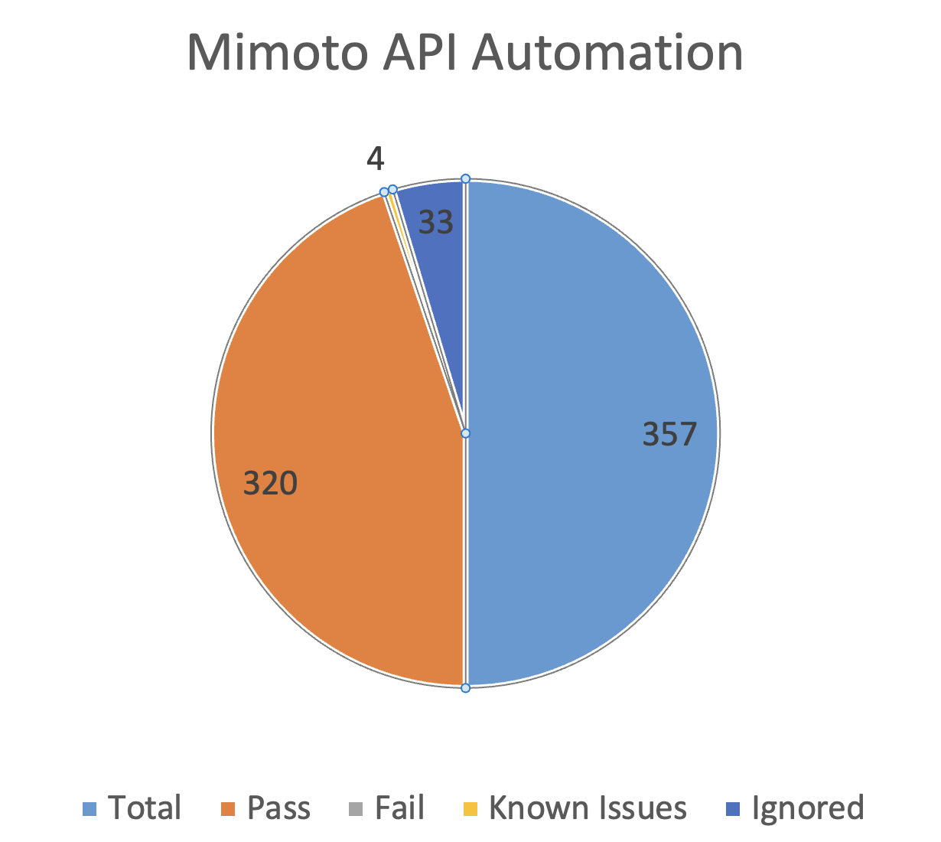

Known Issues Metrics
This section focuses on a separate category of issues that are known but not addressed in the current release. It provides a count and severity distribution for these defects across releases.
Table 4: Defect Metrics for the known issues
Blocker | Critical | Major | Minor | Total
0 | 0 | 194 | 45 | 239

Known Issues Table Representation Chart
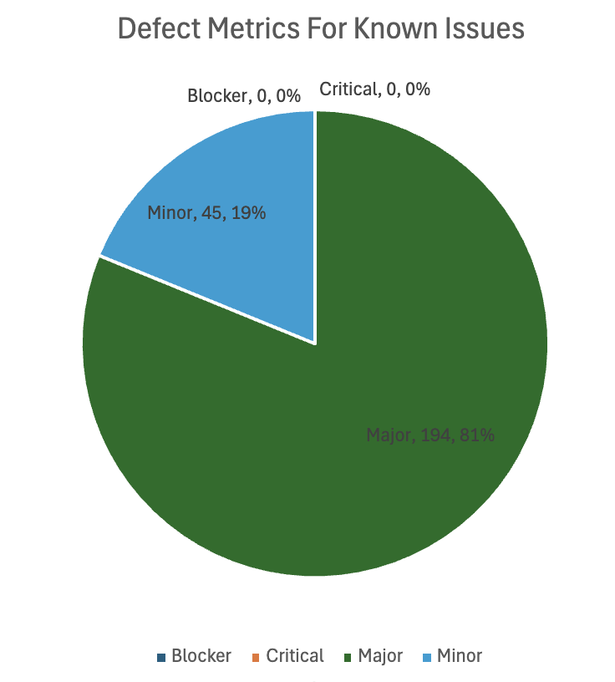

Conclusion
This section summarizes the outcome of QA validation for the patch release. This release is limited to addressing the defect “INJI Wallet – VP verification with iOS wallet is not working,” identified during INJI Verify testing.
From the QA perspective, sanity testing has been successfully completed to validate the fix, and basic verification has been carried out on INJI Mobile across supported platforms to ensure no impact on critical functionalities.
Given the limited scope of this release, comprehensive functional, configurability, and extensibility testing, as well as full regression execution metrics, are out of scope.
Based on the results of the sanity and basic validation performed, the build is recommended for release, as the identified issue has been addressed and no critical or blocking defects have been observed during the verification.

QA Approval
The build has successfully met the defined exit criteria and is recommended for Patch Release. The approval is based on the following conditions:
- Sanity: 100% of planned scenarios executed.
- Defect Status: No Blocker defects remain open.
- Test Environment Stability: The test environment remained stable throughout the execution cycle.

Table 5: Report is signed off details
Name | Functional Role | Responsibilities
Chaitanya K | QA Manager
Ragini Krishna | Senior QA Manager

Appendix
This includes additional reference information for the report. It contains a history of document versions and a list of acronyms and their meanings.

Appendix A: Versions
 | Date | Author | Reviewers
V2.0 | 06/05/2026 | Nitin Hegde | Chaitanya K  Ragini Krishna  Nitin Hegde

Appendix B: Acronyms
Acronym | Literal Translation
MOSIP | Modular Open-Source Identity Platform
UIN | Unique Identification Number
VID | Virtual Identification
SVG | Scalable Vector Graphics
SD-JWT | Selective Disclosure - JSON Web Token
VC | Verifiable Credentials
OpenID4VP | OpenID for Verifiable Presentations
PDI | Presentation During Issuance

END OF DOCUMENT

